**REGISTRATION FORM (in Euros)**

**Before After NuMeD/IAEA**

**October 14th 2024 October 15th 2024 members and TSRM1**

**Practical course2: [ ] 800 Euro [ ] 1000 Euro [ ] 650 Euro**

1Only for Radiology technicians, Students, NuMeD and IAEA scholars

2There will be an Italian track and an English track. Both for Nuclear Medicine physicians or Technicians and Biologists.

All will receive European certification by UEMS-EACME. Registration includes access to the meeting, white coat, gloves, labelling kit, 1 lunch, 1 social dinner, 2 coffee breaks, congress bag, 5 years registration to NuMeD, free download of all lectures, SOP and guidelines.

Payment of registration fees should be made by bank transfer to: **Nuclear Medicine Discovery**, UniCredit bank, **IBAN**: IT66H 02008 05312 000401239779; **BIC/SWIFT**: UNCRITM1C37

**First Name**: …………………………….… **Family name/surname**: ………………………………………………..

**Profession/qualification:** ……………………………………………………………………………………………………

**VAT n°:** …………………………………..…….. **Home address:** …………..……………………………………………….

**City**: ………………..………………… **Country**: ……………………………..……… **Post-code:** …………….………...

**Institution**: ………………………………………………………………………………………………………….……………...

**E.mail:** ………………………………………………………….…….. **Mobile phone**: ……………………………………..

Please send this registration form with a copy of your bank transfer to: [**info@nuclearmedicinediscovery.org**](mailto:info@nuclearmedicinediscovery.org)

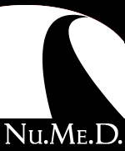 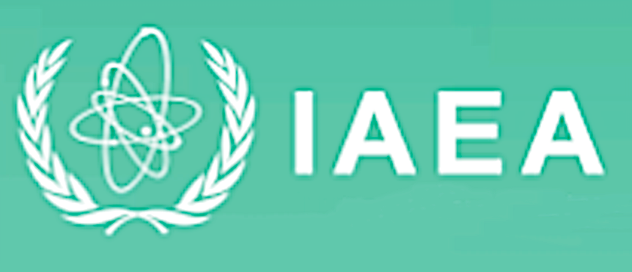 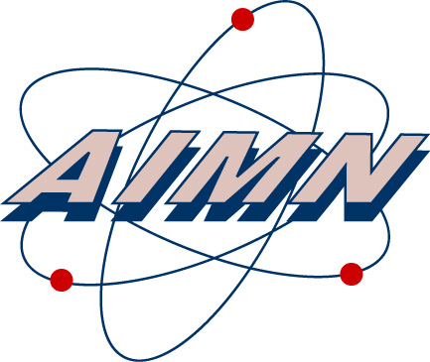

**For further information please go to:** [**https://www.nuclearmedicinediscovery.org/events.asp**](https://www.nuclearmedicinediscovery.org/events.asp)